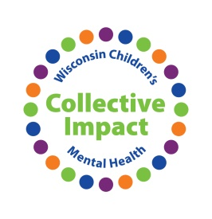
Enhancing Family Engagement by Understanding Cultural and Historical Trauma
Action Plan
This Action Plan is for your personal use. You are encouraged to complete it with the ideas you learn in this workshop and then take it back to your organization for discussion on becoming more aware of cultural and historical trauma.

What are 3 concrete things you learned from the panel in understanding cultural and historical trauma-informed care that you can take back to your organization for discussion?
- ___________________________________________________________________________

- ___________________________________________________________________________

- ___________________________________________________________________________

What are 3 things that you can do as an individual in your organization to be more aware of cultural and historical trauma?
- ___________________________________________________________________________

- ___________________________________________________________________________

- ___________________________________________________________________________

What are 1 – 3 challenges/barriers you anticipate facing in being more understanding of cultural and historical trauma in your organization? What can you do to address those?

Challenge | Addressing Challenge

Who will you need to involve to move your organization in being more aware of cultural and historical trauma?

Goal: ______________________________________________________________________________

___________________________________________________________________________________

Steps to Achieve Goal

 | Task | Responsible | Timeframe
1
2
3
4
5
6
7
8
9
10

Comments/Notes:

