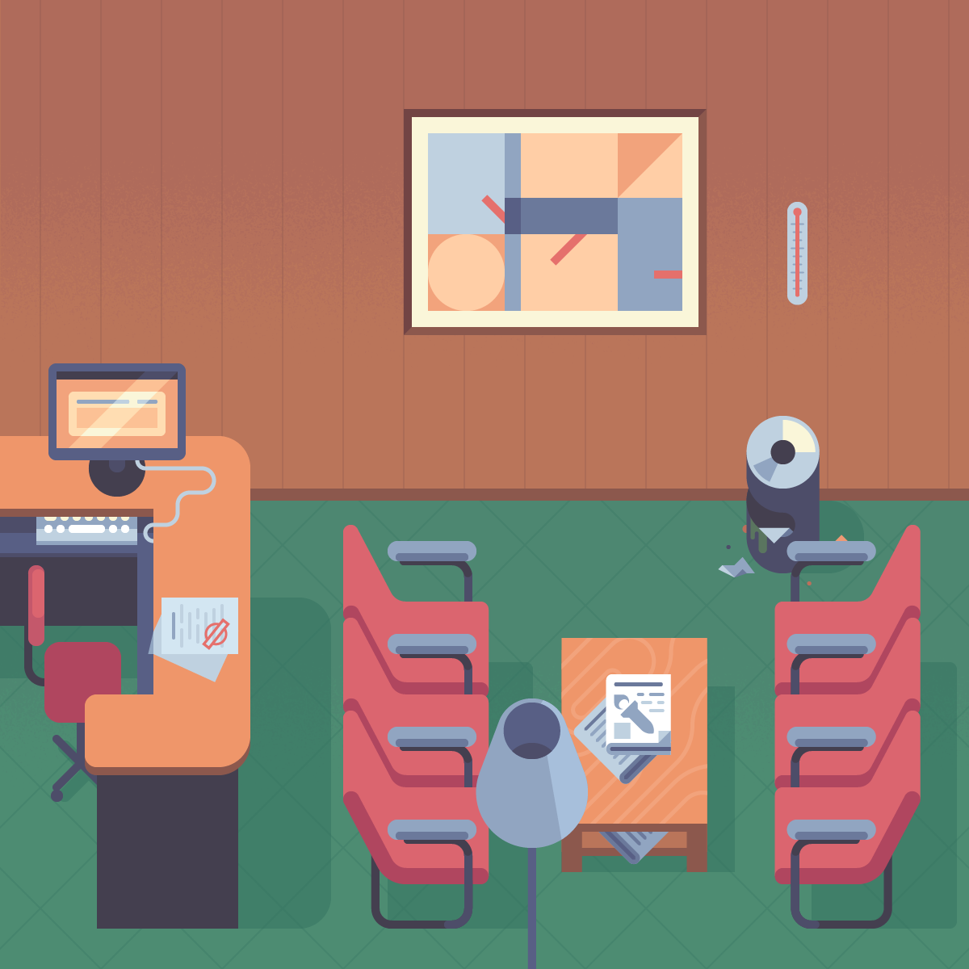

NON-TRAUMA INFORMED SPACE

http://yourexperiencesmatter.com/learning/safe-spaces/trauma-informed-space/
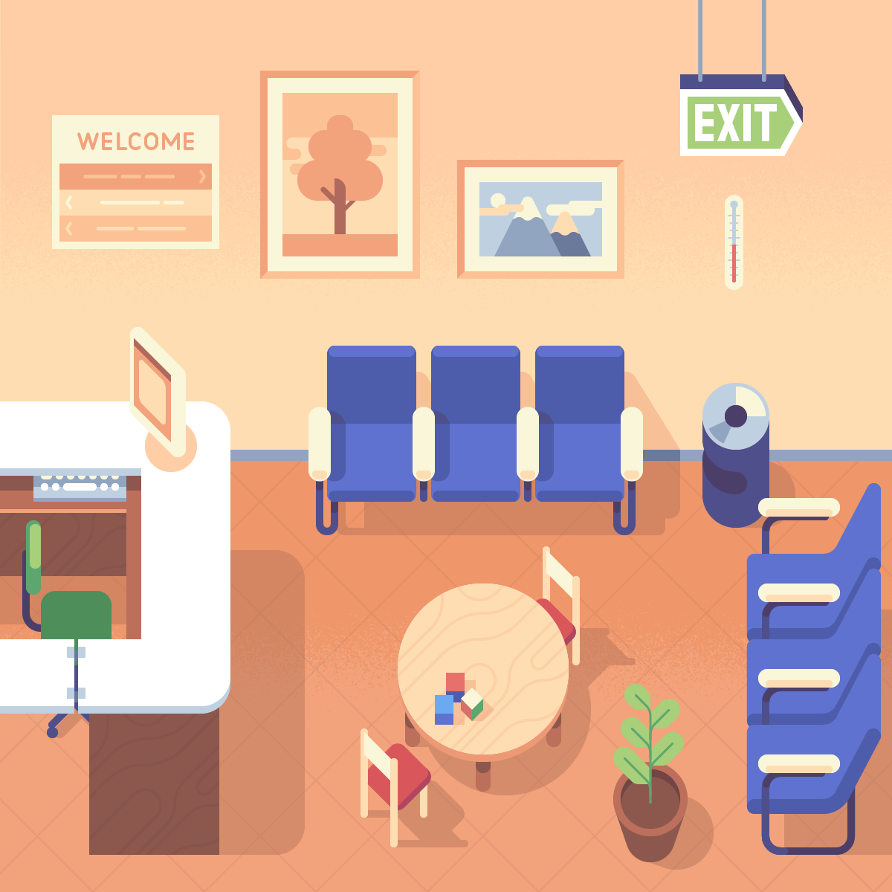
TRAUMA INFORMED SPACE

http://yourexperiencesmatter.com/learning/safe-spaces/trauma-informed-space/

SAFE ENVIRONMENT

- The physical or social setting in which people live or interact in – often referred to as milieu.
- Creating physical safety involves creating an environment where people can interact not just with each other but also with the physical items in it. Since traumatized individual’s perception and experiences of the world can be altered, careful consideration should be made when spaces such as entry ways, hall ways, waiting rooms, signage, bathrooms, outdoor spaces, bedrooms, medical equipment and furniture are built and purchased to reduce the chances of re-traumatization.
Here are some factors to consider when creating a safe environment:
- Signage – Is the wording framed as what you can do vs. what you can’t do?
- Are your waiting areas welcoming and friendly with comfortable furniture with maintenance up to date?
- Do you have information in client/patient areas that is intended to assist staff but may be triggering for clients/patients?
- Provide culturally appropriate symbols of safety in the physical environment (e.g. the LGBTQI rainbow flag, culturally diverse posters).
- Artwork – Is the art work displayed calming to most people? Some abstract artwork has been found to be triggering. Natures scenes are described as the most calming.

http://yourexperiencesmatter.com/learning/safe-spaces/physical-safety/environment/

However, if we have experienced trauma, our responses may not always help us become regulated. It is in these instances that a safe, trauma informed space like a Comfort Room can help people explore sensory strategies with support from safe and trusted caregivers. Below are some strategies which people have reported as being helpful depending on where they are on the arousal continuum.
Too Low (Hypo-alert)  ALERTING | Too Heightened (Hyper-alert)  CALMING
- Standing on a balance board or disc ‘o’ sit (challenging the vestibular system)  - More vivid colors  - Music with an upbeat tempo  - Fidgets that provide light touch (ex; koosh balls or feathers)  - Sitting on a therapy ball  - Herbal Teas / Ice Water  - Compression Garments/Weighted blankets/items*  - Heavy input (ex., resistance bands) | - Rocking back and forth on a rocking chair (vestibular system)  - Low lighting  - Pictures of nature scenes or serene environments  - Calming, repetitive music/sounds  - Fidgets that provide deep pressure (ex: stress balls or clay)  - Bean bag-like chair (deep pressure, provides a lot of proprioceptive input into the whole body)  - Chewing gum  - Herbal Teas  - Compression Garments/Weighted blankets/items*  - Heavy input (ex., resistance bands)
Champagne, T. & Sayer, E. (2003). The effects of the use of the sensory room in psychiatry.: A quality improvement study. Retrieved from http://www.ot-innovations.com/restraint-reduction/seclusion-and-restraint-reduction-initiative/. Champagne, T. & Stromberg, N. (2004). Sensory approaches in inpatient psychiatric settings: Innovative alternatives to seclusion & restraint. Journal of Psychosocial Nursing, 42(9) 35-44 Champagne, T. (2011) http://www.ot-innovations.com/.Loukas, K. (2011, June) Occupational placemaking: Facilitating Self-Organization through the use of a sensory room. Mental Health Special Interest Section Quarterly, 1-4.MacDaniel, M. (2009) Comfort Rooms: A preventative tool used to reduce the use of restraint and seclusion in facilities that serve individuals with mental illness: Ideas and instructions for implementation. pp75-76. Novak et al. (2014). Pilot study of a sensory room in an acute inpatient psychiatric unit. Journal of Australian Psychiatry, 20 (5) 401-406.Shanker, S. (2013) Calm, alert and happy. Queens Printer for Ontario, 1-6.Steele, W. & Kuban, C. (2010). Structured sensory trauma interventions. Reclaiming Children and Youth, 18(4). 29-31.Warner et al. (2013). Can the body change the score? Application of sensory modulation principles in the treatment of traumatized adolescents in residential settings. Journal of Family Violence. 28, 729-738.

Use Neutral and Warm Colors

7 Best Colors for Healing:
Healing colors are the colors that influence mood, calm the nervous system and make the environments less provoking and peace inducing. Over the centuries, many cultures across the world have employed colors for their healing powers. Even today, Chromotherapy is an important tool for gentle healing treatment. In this guide, we will discuss seven of the best colors for healing as well as the ways to use these colors to recover from disease. Using these healing colors for a room or clothing, you can significantly change the patient’s mood and bring about many

1. Red
Red is a passionate and warm color which induces vitality and stimulates energy. It increases adrenaline and elevates blood pressure-so avoid using it when the patient is suffering from hypertension. This could be the reason why red is used only moderately in hospitals. At home though, you can use this color for stimulating appetite in weak patients. Red can also alleviate depression. It is one of the top healing colors for enhancing sexual appetite and overall vitality.

2. Orange
According to color healing therapy, orange is one of the best colors for hospitals and particularly for children’s rooms. Orange radiates warmth and is associated with joy and happiness. In fact: even oranges which are packed with Vitamin C-the powerful antioxidant- are known to heal and fight free radicals to boost immunity. Therefore, as far as cancer healing colors go, orange is an important color in the color healing chart.

3. Yellow
Search for healing colors for hospitals and yellow would be high up in the list. This bright and cheerful color can help stimulate intelligence and detoxify the body and mind to heal patients quickly. Yellow is particularly recommended for patients with skin problems. It can inspire creativity in people who feel sluggish or lethargic. Avoid overuse of yellow as it can hamper the digestive health and lead to stomach problems and insomnia.

4. Green
Green color is known for its balanced healing properties. It is a restful color that symbolizes growth and renewal. It also encourages comfort and equilibrium and is particularly beneficial for the heart, lungs and circulatory system.

5. Blue
This spiritual color is also the color of the sky and sea. Blue is an important healing color as it is linked with calm and serenity. It helps lower blood pressure and can reduce rapid heart rate. Blue is relaxing for the mind and body. It is associated with organs like eyes, ears and nose and involved with the senses of smell, sight and sound.

6. Pink
Pink is feminine yet a soothing color that shows caring and affection. It is a protective and compassionate color that heals and soothes. This lighthearted color can stimulate happiness. Too much of bright pink might stimulate energy and incite passionate behavior just like its distant cousin Red. Pink can be however be safely useful in hospitals and prisons to reduce erratic behavior.

7. Purple
Both, purple and violet, as well as its related shades like lilac and lavender are connected with spirituality. These healing colors are also linked with perception, higher consciousness and insight. Health wise, these colors are linked with the cerebral and nervous systems.
https://www.color-meanings.com/7-best-colors-healing/

